Ex no: 15

Date:

**HIGH LEVEL PROGRAMMING EXTENSONS (procedures)**

**AIM:**

Creating a simple procedure to get all the records from the table.

1. **To create table student_info:**

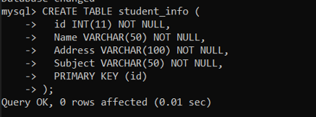

1. **Inserting values into student_info table:**

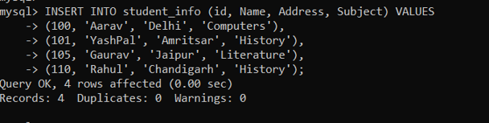

1. **Implementing procedure:**

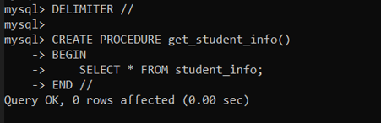

1. **Using CALL command to get student info:**

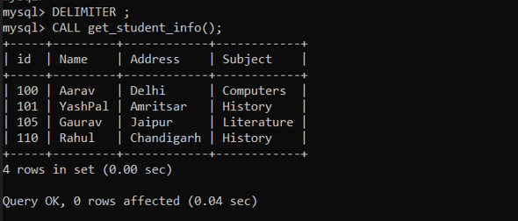

**RESULT:**

Student info table is created and executed using call command.